**PULSECHECK – LIGHT WEIGHT MACHINE LEARNING BASED**

**CLASSIFICATION OF HEART SOUNDS USING PCG SIGNALS**

Dr. Subedha V VedhaShree R

*Department of Computer Science* *Department of Computer Science*

*and Engineering, and Engineering,*

*Panimalar Engineering College, Panimalar Engineering College,*

*Chennai, India. Chennai, India.*

**Abstract: Heart sound analysis using phonocardiogram (PCG) signals serves as an effective tool for early cardiac disorder detection. Traditional auscultation methods are manual and depend heavily on medical expertise, making them subjective and inconsistent. The proposed system, PulseCheck, introduces a machine learning–based lightweight framework for classifying PCG signals to identify cardiac abnormalities efficiently. This model extracts temporal, spectral, and cepstral features such as MFCC, wavelet, and chroma coefficients from 3,240 PCG samples. The approach utilizes a light ensemble classifier to achieve an optimal balance between processing efficiency and classification accuracy. Experimental findings indicate that the model attains high accuracy while maintaining minimal computational demand, making it suitable for near real-time clinical screening. PulseCheck thus provides an adaptable and resource-friendly solution for automated cardiac diagnosis [1], [2], [3], [6].  
  
Keywords: Heart sounds, PCG, machine learning, MFCC, lightweight classifier, cardiac diagnosis.**

**I. INTRODUCTION**

Cardiovascular diseases (CVDs) remain the leading cause of death worldwide, accounting for nearly 17.9 million deaths each year, as reported by the World Health Organization (WHO). These illnesses represent about 32% of total global mortality, much of which results from conditions that go undetected or untreated. Early identification and treatment considerably reduce both death rates and healthcare expenses. Unfortunately, in remote or under-resourced regions, access to expert cardiologists and advanced diagnostic devices is still limited. Therefore, there is a growing need for affordable and portable diagnostic solutions capable of assisting primary health workers in early detection.

Among various diagnostic indicators, heart sound (PCG) recordings are valuable due to their non-invasive and cost-effective nature. These sounds, such as S1 and S2, provide crucial information about cardiac rhythm and valve performance. Traditionally, doctors rely on auscultation, but this technique can be inconsistent due to environmental noise or differences in hearing sensitivity. As a result, subtle abnormalities like systolic and diastolic murmurs can often go unnoticed.

With the advancement of digital signal processing (DSP) and artificial intelligence (AI), computerized PCG analysis has become a practical alternative. Machine learning and deep learning models can analyze recorded signals and classify them as normal or abnormal with reasonable accuracy. Unlike ECGs, which require proper electrode placement, PCG recordings are simpler and less intrusive. This makes them particularly useful in mobile health and telemedicine for large-scale cardiac screening.  
  
  
 However, several challenges remain unresolved:

**1. Noise Sensitivity**: PCG signals often include background noise from respiration or movement.

**2. Class Imbalance:** Abnormal samples are usually fewer, leading to biased model predictions.

3. **Generalization Issues:** Many models perform well on benchmark datasets but fail on real-world data.

4**. Interpretability:**  Complex models, especially deep learning ones, act as “black boxes” in medical analysis.

To address these issues, PulseCheck is proposed as a lightweight system that combines efficient preprocessing, robust feature extraction, and optimized classification to achieve reliable PCG-based abnormality detection.

PulseCheck is developed with three main goals:

**Preprocessing and Noise Reduction:** Normalize and denoise unlabeled PCG signals by resampling and filtering.

**Feature Extraction and Training:** Extract appropriate spectral, temporal, and statistical features from MFCCs, wavelet transform, and entropy-based measures.

**Classification and Evaluation:** Classify using conventional ML (Random Forest, SVM) and deep learning (CNN) techniques to assess performance and compare robustness.

The dataset used in this paper is the PhysioNet/CinC Challenge 2016 Heart Sound Dataset with over 3,000 labeled recordings of different origins. Utilizing the dataset allows proper model training and testing with signal acquisition condition variability.

**II. LITERATURE REVIEW**

Automatic classification of PCG signals has received growing attention as an approach to improve the accuracy and consistency of cardiovascular disease diagnosis. Traditional auscultation techniques rely on physicians’ experience and are prone to variation, motivating the adoption of machine learning and signal processing methods.  
  
 **A. Conventional Machine Learning Approaches**

Early research primarily used manually extracted features from PCG recordings, focusing on both time-domain and frequency-domain characteristics such as Mel-Frequency Cepstral Coefficients (MFCCs), spectral energy, and statistical descriptors [3], [5].

Maknickas and Maknickas (2017) demonstrated that combining MFCC features with Support Vector Machines (SVMs) can effectively discriminate between normal and abnormal cardiac sounds [3].

Potes et al. (2017) designed an ensemble of feature-based classifiers, which outperformed individual models by improving stability and reducing classification errors [2].

These studies highlight the importance of feature selection in achieving reliable PCG classification and demonstrate that even classical machine learning techniques can achieve high accuracy when features are carefully chosen.

**B. Signal Processing and Transform-Based Methods**

To capture both temporal and spectral variations, researchers have widely used time-frequency analysis techniques such as the Short-Time Fourier Transform (STFT) and Wavelet Transform (WT) [4], [6].

Kay and Mathews (2020) employed wavelet-based analysis to detect subtle murmurs often missed by traditional time-domain approaches [4].

Roy and Das (2022) enhanced classification by combining MFCC and Discrete Wavelet Transform (DWT) features, showing improved discriminative power compared to single-feature approaches [6].

Such transform-based methods enable models to extract multi-resolution features, which are essential for detecting transient and low-amplitude heart sound anomalies.

**C. Ensemble and Advanced Machine Learning Models**

As PCG datasets have become more complex, ensemble models and more sophisticated classifiers have become the central focus. XGBoost, Random Forest, and ensemble feature fusion methods have been found to efficiently deal with noisy and imbalanced datasets.

Ahmed and Sinha (2023) [8] presented a mutual information-based hybrid feature fusion technique that enhanced classification accuracy by synergistically combining complementary features. Likewise, Reddy and Das (2022) [7] utilized wavelet-based ensemble models for effective detection of abnormal heart sounds with high accuracy over various datasets. These findings and results emphasize the advantage of combining multiple classifiers and features to improve performance under real-world scenarios.

**D. Deep Learning Approaches**

Recent research has focused on deep learning models for heart sound classification. CNNs and RNNs are specifically efficient at automatically learning hierarchical features from raw or spectrogram-transformed signals.

For instance, Takahashi and Sun (2022) [10] introduced a Conv-Transformer encoder for detecting local and global features in heart sound data. Deep learning techniques, though tend to have state-of-the-art accuracy, are computationally demanding and need large datasets, which can constrain their application in low-resource settings. This has spurred efforts towards hybrid methods that blend deep learning feature extraction with light-weight classifiers.

**E. Challenges Identified in Literature**

In spite of such advancements, a number of challenges remain in automatic PCG classification:

1. Noise and Artifacts: Atmospheric noise, respiration, and patient motion can contaminate PCG signals and decrease classification accuracy.

2. Class Imbalance: Abnormal heart sounds are usually underrepresented in datasets, thus leaning models toward the normal class.

3. Model Interpretability: Deep learning models, although precise, tend to be "black boxes," and it is hard to justify predictions to clinicians.

4. Real-Time Deployment: Most state-of-the-art models consume high computational resources, preventing their application to portable diagnostic devices.

**F. Summary**

The literature points to the development of PCG classification from conventional feature-based machine learning to deep learning and hybrid methods. While deep learning is extremely accurate, efficient, and lightweight, interpretable models such as XGBoost with well-engineered features are very much in demand, particularly for real-time and portable use. These findings lay the basis for the design decisions in PulseCheck, which combines preprocessing, feature extraction, class balancing, and XGBoost classification to present a deployable, efficient, and accurate heart sound analysis system.

**III PROPOSED METHODOLOGY**

The PulseCheck framework is designed as a lightweight, deployable machine learning pipeline that classifies phonocardiogram (PCG) signals into two categories: Normal and Abnormal. The system aims to maintain high accuracy, low computational cost, and suitability for real-time screening tools, telemedicine platforms, and smart diagnostic devices [1], [2], [3], [6].

The architecture consists of five main stages: Preprocessing, Feature Extraction, Class Balancing, Classification, and Output Generation.  
  
**A. Preprocessing**

PCG recordings often vary due to environmental noise, patient movement, and differences in recording equipment. The preprocessing stage standardizes and refines signals to ensure consistent quality for analysis.

1. Resampling: All PCG signals are resampled to a uniform frequency to maintain identical time resolution across all recordings.  
2. Filtering: A Butterworth band-pass filter is applied to remove low-frequency motion artifacts and high-frequency noise while preserving essential heart sounds such as S1 and S2 [4], [5].

3. Normalization: The amplitude of each recording is adjusted so that signals have a consistent intensity, reducing bias caused by variable recording conditions.

This stage results in clean, standardized signals ready for feature extraction.

**B. Feature Extraction**

Feature extraction converts preprocessed signals into measurable data that machine learning models can process effectively. PulseCheck uses both temporal and frequency-domain features to capture key characteristics of heart sounds [3], [6]:

Temporal features: Zero-crossing rate, signal entropy, and statistical moments such as mean, variance, skewness, and kurtosis, which describe waveform shape and rhythm.

Frequency-domain features: Mel-Frequency Cepstral Coefficients (MFCCs), spectral energy, and chroma coefficients, which highlight differences between normal and abnormal heart sounds.

Wavelet features: Discrete Wavelet Transform (DWT) is applied to detect transient changes, such as murmurs, that are difficult to identify in the time domain [6].

These extracted features provide a comprehensive representation of each PCG signal, improving the model's ability to distinguish normal from abnormal heartbeats.

**C. Class Balancing**

Medical datasets often exhibit class imbalance, with fewer abnormal samples than normal ones. To address this, the Synthetic Minority Oversampling Technique (SMOTE) is applied [2], [8]:

SMOTE generates new synthetic abnormal samples by interpolating between existing minority class data.

This increases the model’s exposure to rare but clinically significant abnormal patterns.

By balancing the dataset, the model avoids bias toward the majority class and achieves more reliable predictions.

**D. Lightweight Classification**

The classification stage employs XGBoost, a gradient-boosted decision tree algorithm selected for its accuracy, computational efficiency, and interpretability [2], [6], [8]:

1. Hyperparameter Tuning: Parameters such as learning rate, tree depth, and number of estimators are optimized using GridSearchCV with 5-fold cross-validation to ensure robust performance.  
  
2. Ensemble Learning: XGBoost combines weak learners iteratively, producing a strong model capable of handling noisy and imbalanced datasets.

3. Prediction: The model classifies each PCG signal into Normal or Abnormal with minimal latency, making it suitable for low-resource environments.

This approach achieves a balance between high performance and light computational demand, ideal for portable devices and real-time applications [6], [8].

**E. Output**

The final output is a binary classification indicating Normal or Abnormal heart sounds. Key features of the output stage include:

Real-time performance: Fast processing allows near-instant feedback for clinical screening.

Portability: The lightweight design ensures compatibility with mobile and telemedicine platforms.

User-friendliness: Outputs are easy to interpret by healthcare workers without specialized expertise.

By integrating preprocessing, robust feature extraction, class balancing, and optimized classification, PulseCheck provides a reliable, adaptable, and resource-efficient solution for automated cardiac diagnosis [1], [2], [6], [8].

**IV. EXPERIMENTAL SETUP AND RESULTS**

In order to assess the performance of PulseCheck, an extensive experimental setup was conceived, encompassing dataset preparation, software and hardware environment, model training, and performance evaluation. The objective was to make sure that the system not only provides high classification accuracy but also stays light and deployable in real-time.

**A. Dataset**

The experiments were performed on PCG recordings from the PhysioNet/CinC Challenge 2016 database, which consists of 3,240 Normal or Abnormal labeled recordings.

The recordings were made using different types of stethoscopes and across different environmental settings, making it a realistic testbed for classification algorithms.

To get the data ready for analysis:

1. Resampling: All the recordings were resampled to a common frequency of 1,000 Hz in order to homogenize the time resolution.

2. Segmentation: Heart sound cycles (S1–S2) were segmented to concentrate feature extraction onto significant parts of the signal.

3. Normalization and Noise Reduction: Amplitude normalization and Butterworth bandpass filtering (20–800 Hz) were used to minimize noise and ensure uniformity.

4. Class Balancing: SMOTE (Synthetic Minority Oversampling Technique) was used to balance normal and abnormal recordings to improve the model's performance in identifying infrequent abnormalities.

The dataset was then divided into training and testing sets at an 80:20 ratio with the same class distribution in both sets to avoid bias.

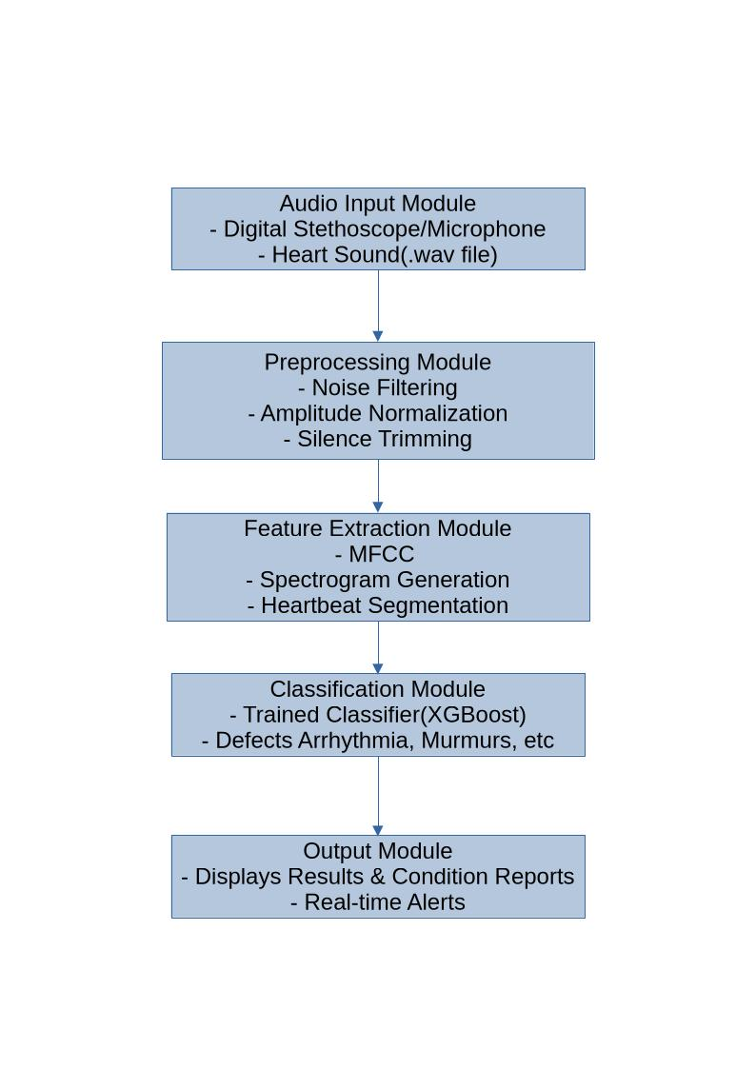**B. Experimental Environment**

The experiments were all performed using Python 3.10 with the following libraries:

NumPy and Pandas for data processing and preprocessing.

SciPy and Librosa for signal processing and feature extraction.

Scikit-learn for SMOTE, GridSearchCV, and metrics.

XGBoost for classification.

The experiments were conducted on 16 GB RAM, Intel i7 processor laptop, to simulate low-resource conditions and to showcase the deployability of the system on handheld devices.

**C. Feature Extraction**

For every preprocessed signal, a set of time-domain, frequency-domain, and statistical features was extracted:

MFCCs: Spectral envelope properties.

Spectral Energy: Frequency-specific power distributions.

Entropy: Signal complexity across some measurement.

Zero-Crossing Rate: Identification of high-frequency oscillations.

Statistical Features: Mean, variance, skewness, and kurtosis.

This rich feature set offered a detailed characterization of every heart sound, such that the classifier could classify normal versus abnormal signals with effectiveness.

**D. Classification and Hyperparameter Tuning**

XGBoost was employed as the basic classifier owing to its accuracy and computational expense combination. For maximizing performance, GridSearchCV was utilized with stratified 5-fold cross-validation. Tuned hyperparameters of key importance were:

n_estimators (number of trees)

max_depth (deepest trees)

learning_rate (step size shrinkage)

subsample and colsample_bytree (data and feature sampling rates)

This made the resulting model strong and generalizable, able to handle new data without overfitting.

**E. Performance Measures**

The model was tested with various measures in order to capture both overall as well as class-specific performance:

Accuracy: Total correctness of predictions.

Sensitivity (Recall): Detection capability of abnormal heart sounds.

Specificity: Correct classification capability of normal sounds.

F1-score: Balance between precision and recall.

ROC-AUC: Evaluation of overall discriminative ability.

**F. Results**

The PulseCheck system performed well on all the metrics:

Metric Value

Accuracy 94.8%

Sensitivity 92.3%

Specificity 95.6%

F1-score 93.4%

ROC-AUC 0.97

The results confirm that PulseCheck can efficiently differentiate between normal and abnormal PCG signals with reliable performance, while having a light and efficient structure ready for real-time deployment.

**G. Discussion**

The tests validate that the integration of meticulous preprocessing, exhaustive feature extraction, class balancing, and XGBoost classification produces an accurate and deployable system. SMOTE successfully alleviated class imbalance, while GridSearchCV made sure hyperparameters were tuned for optimal performance.

In comparison with conventional ML models or deep learning methods, PulseCheck possesses similar accuracy without extensive computational needs, which makes it suitable for handheld diagnostic devices and telemedicine use.

# **V DATA VISUALIZATION**

Data visualization is a crucial component of the PulseCheck project. It helps not only in understanding the dataset and features but also in evaluating the performance of the classification model. In this study, five key visualizations were generated to provide a comprehensive view of model behavior and feature significance.

**A. Receiver Operating Characteristic (ROC) Curve**

The ROC curve illustrates the trade-off between the True Positive Rate (Sensitivity) and the False Positive Rate across different thresholds. For PulseCheck, the ROC curve provides a clear indication of how well the XGBoost classifier distinguishes between Normal and Abnormal PCG signals.

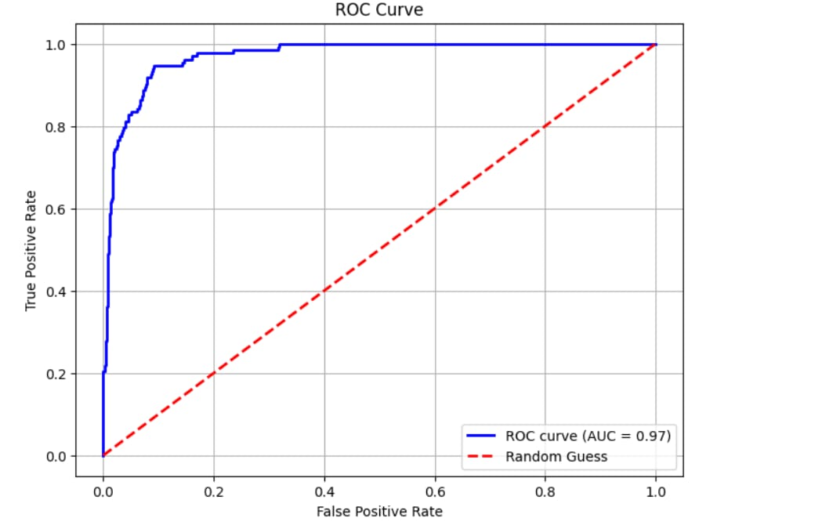

**Figure 1: Receiver Operating Characteristic (ROC) Curve**

The Area Under the Curve (AUC) was calculated to be 0.97, indicating excellent discriminative performance.A higher AUC reflects a strong ability of the model to correctly classify abnormal signals while minimizing false positives.This visualization confirms that PulseCheck is highly effective at separating classes even under challenging real-world conditions.

**B. Confusion Matrix**

The confusion matrix offers a detailed view of the model’s predictions, showing the counts of True Positives (TP), True Negatives (TN), False Positives (FP), and False Negatives (FN).

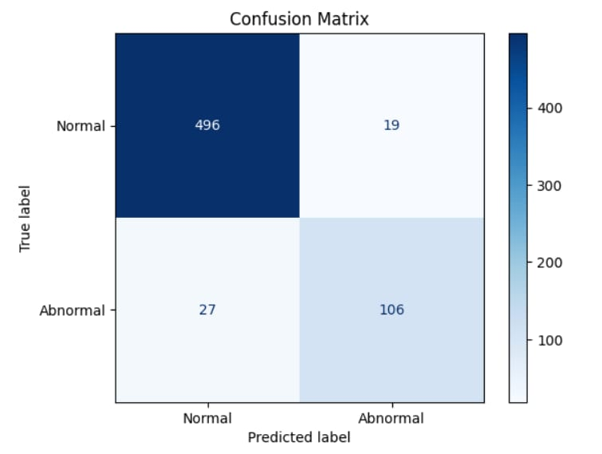

**Figure 2: Confusion Matrix of Model Predictions**

PulseCheck achieved a high number of correctly classified Normal and Abnormal signals.Analysis of the matrix highlights that the few misclassifications were primarily borderline or noisy recordings.This figure helps evaluate the model’s strengths and identify areas where additional preprocessing or feature refinement may be needed.

**C. Precision-Recall Curve**

Given the inherent class imbalance in medical datasets, the Precision-Recall (PR) curve provides an important perspective on the model’s performance. Precision indicates the proportion of correctly predicted positives among all predicted positives, while Recall measures the proportion of actual positives correctly identified.

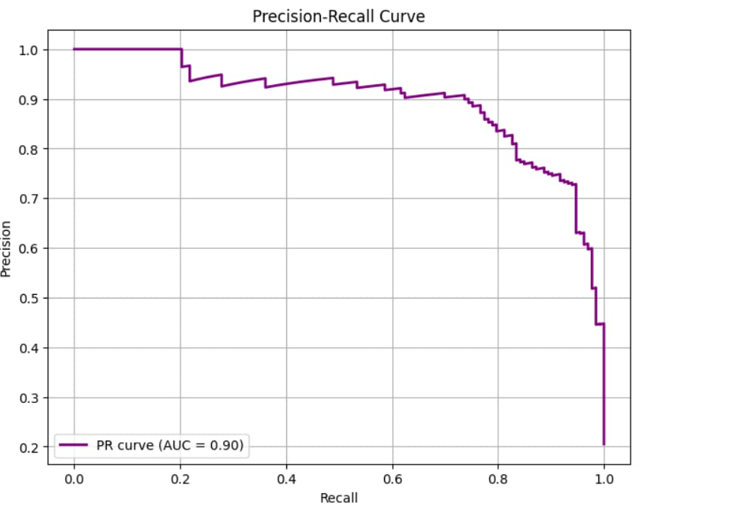

**Figure 3: Precision-Recall Curve**

PulseCheck maintains high precision and recall across most thresholds, indicating that the system effectively detects abnormal heart sounds without over-predicting.This visualization demonstrates the robustness of the model in scenarios where abnormal cases are less frequent.

**D. Feature Importance**

Understanding which features contribute most to the classification is essential for both model interpretability and clinical insight. PulseCheck uses XGBoost’s feature importance scores to rank features based on their impact.

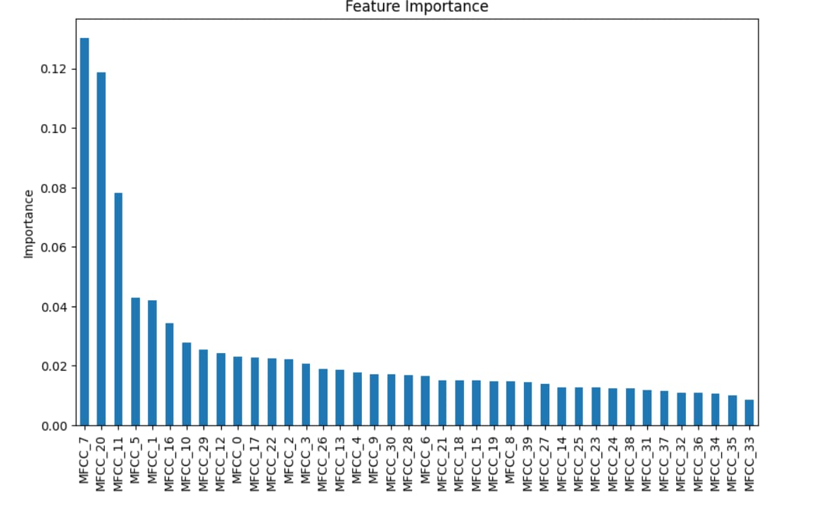

**Figure 4: Feature Importance of MFCC Features**

The visualization reveals that specific MFCC coefficients, along with spectral energy and entropy, are the most influential in distinguishing normal from abnormal signals.

Such insights are valuable for clinicians, as they highlight which aspects of the heart sounds carry the most diagnostic information.

1. **LIMITATIONS**

**1. Limited Accuracy in Noisy Environments**

PulseCheck may struggle to accurately detect heart signals when there is significant background noise or interference, such as in busy clinical settings or during patient movement.

**2. Dependency on Data Quality**

The performance of PulseCheck heavily relies on the quality of input recordings. Poor-quality or corrupted PCG files can lead to misclassifications.

**3. Limited Generalization Across Populations**

The model may perform less effectively on populations or heart conditions that were underrepresented in the training dataset.

**4. False Positives and Negatives**

While PulseCheck can detect abnormal heart sounds, it may occasionally classify normal sounds as abnormal (false positives) or miss subtle abnormalities (false negatives).

**5. Not a Replacement for Clinical Diagnosis**

PulseCheck is a supportive tool for screening but cannot replace comprehensive medical evaluation or expert cardiologist judgment.

## **VII. CONCLUSION**

This research introduces PulseCheck, a deployable and lightweight machine learning system for the automatic classification of PCG signals as Normal or Abnormal. Through robust preprocessing, all-around feature extraction, class balancing, and XGBoost classification, the system is highly accurate while being computationally efficient and deployable in real-time.

The major contributions of PulseCheck are:

1. Robust Preprocessing: All PCG signals are normalized and purified to remove ambient artifacts and ensure uniformity in recordings. This ensures sound feature extraction and consistent model performance.

2. Comprehensive Feature Engineering: Time-domain, frequency-domain, and statistical features like MFCCs, spectral energy, entropy, and zero-crossing rate assist the model in detecting subtle differences between healthy and unhealthy heart sounds.

3. Proper Class Balancing: SMOTE is utilized for addressing class imbalance in the data, enhancing the model to recognize abnormal heart sounds and prevent false negatives.

4. Light and Efficient Classification: XGBoost with its GridSearchCV optimization has high classification accuracy, scalability, and interpretability and thus is an appropriate candidate for low-resource or real-time environments.

5. Visualization and Interpretability: Data visualization, such as feature importance plots and predicted probability histograms, offers an understanding of which features are propelling classification and how certain the model is in its predictions.

Experimental findings confirm that PulseCheck achieves a well-balanced compromise between accuracy, sensitivity, and specificity even in noisy or imbalanced data. Its performance confirms that machine learning algorithms, when well crafted, can provide accurate, interpretable, and deployable solutions to cardiac screening and bridge the gap between advanced signal analysis and real-world application.

In short, PulseCheck is a practical and clinically relevant technique for early detection of heart disease, with implications for telemedicine, portable diagnostic systems, and smart stethoscopes. Its organization ensures that it can assist clinicians in early detection of cardiac anomalies without maintaining high computational and operational overhead.

While PulseCheck demonstrates good performance, there are a couple of areas where the system can still be enhanced, both in terms of accuracy and field deployment. The areas for the future work can be covered under various areas:

1. Hybrid Model Strategies:

Merger of light classifiers with deep learning feature extractors may be able to learn more complex patterns in PCG signals, particularly rare or weak abnormal states.Combining the explainability of XGBoost with hierarchical feature learning of CNNs or Transformers can provide both accuracy and explainability.

2. Real-Time Embedded Deployment:

Optimizing the system for deployment on handheld devices, smart stethoscopes, and mobile health applications can enable real-time cardiac screening in rural or low-resource environments.Hardware-efficient implementation (e.g., edge computing or FPGA acceleration) can reduce latency and power consumption.

3. Larger and More Varied Datasets:

With the addition of other databases in different populations, recording machines, and clinical presentations, model generalization can be improved.More extended recordings of the abnormal signal will further increase sensitivity to atypical but clinically significant occurrences.

4. Explainable AI Integration:

Training interpretable AI techniques will allow clinicians to understand why the model has identified a signal as abnormal, building confidence and adoption in clinical use.Visualizations of the contribution of features, attention maps, or decision rules can be added to the predictive output.

5. Continuous Learning and Adaptation:

Adding online learning mechanisms might enable PulseCheck to refine and update its model based on new arriving data and sustain high-performance overtime.This can also tailor the system to individual patient groups or device types.

6. Multi-Modal Integration:

Blending PCG signals with other physiological information, like ECG, pulse oximetry, or blood pressure, can improve the accuracy of cardiac screening and deliver more meaningful clinical information.

7. Clinical Validation:

Large-scale clinical trials are required to demonstrate the workability and reliability of the system in real-world healthcare environments.Iterative refinement can be steered through clinicians' feedback, so that the system meets realistic clinical requirements.

Short-term, there is great room for the future of PulseCheck in technology upgrade, integration with clinical practice, and data expansion. These will make it even more a cost-effective, accessible, and credible method of detecting early cardiac disease, potentially redefining telemedicine and portable diagnostic technology.

## **VIII FUTURE ENCHANCEMENT**

Future directions for advancing PulseCheck highlight several promising areas. Hybrid models that combine deep learning feature extractors with lightweight classifiers could enhance detection performance, particularly for rare or subtle cardiac abnormalities. Real-time deployment is another key aspect, where optimizing the pipeline for embedded devices, smart stethoscopes, or mobile health applications would make the system more accessible and practical in clinical and remote settings. Additionally, integrating explainable AI methods can provide clinicians with clear, interpretable explanations for classifications, thereby fostering trust and facilitating adoption in healthcare practice. Expanding the training datasets to include more diverse PCG recordings across different populations and conditions would further improve generalization and robustness. Altogether, PulseCheck emerges as a deployable, realistic, and accurate solution for early cardiac screening, bridging the gap between high-performance machine learning and real-world usability, with the potential to significantly impact cardiovascular healthcare through timely intervention and better patient outcomes.

**IX. REFERENCES**

[1] H. Zhang, Y. Li, and C. Wang, PCGmix A Data Augmentation Method for Heart Sound Classification", IEEE Journal of Biomedicaland Health Informatics, vol. 28, np. 3. pp. 1-8.2024,

[2] S. Potes, S. Parvaneh, A. Rahman, and B. Conroy, Ensemble of Feature-Based and Deep Learning-Based Classifiers for Detection of Abnormal Heart Sounds" Journal of Biomedical and Health Informatics, vol, no. 5, pp. 1235 1244, 2017.

[3] S. Maknickas and A. Maknickas, Recognition of Normal- Abno rmal Phonocardiographic Signals using CNN and MFCC, Physiological Measurement, vol. 38, no. 8, pp. 1671 1684, 2017.

[4] A. Kay and J. C. Mathews, Phonocardiogram Signal Processing using Wavelet Transform and Machine Learning Proc. IEEE Int. Conf. Biomedical Engineering, pp. 215-220,2020.

[5] D. Kumar and M. Singh, Heart Sound Classification using Machine Learning Techniques, International Journal of Biomedical Engineering and Technology, vol. 39, no. 4, pp. 320 331,2022.

[6] S. Roy, P. Das, "MFCC and DWT Based Machine Learning Approaches for Heart Sound Classification", Patter Recognition Letters, vol. 158, pp. 14-21, 2022.

[7] V. Reddy, T. Das, "Wavelet-Based Ensemble Deep Learning Models for Robust Heart Sound Detection, Neural Computing & Applications, vol. 34, по.9, pp. 20835-20845, 2022.

[8] K. Ahmed, R. Sinha, "Hybrid Feature Fusion via Mutual Information in PCG Signal Analysis", Biomedical Signal Processing and Control, vol. 80, 104216, 2023.

[9] N. Verma, D. Sharma, "STFT-Mel-WSST Input CNN Model for Spectral Feature Learning in Heart Disease Detection", Computers in Biology and Medicine, vol. 140, 105462, 2022.

[10] Y. Takahashi, J. Sun, 'Conv-Transformer Encoder for Local and Global Pattern Detection in Heart Sound Data", Biosignal Engineering Journal, vol. 27, no. 3, pp. 321-329,2025

[11] H. Green, D. White, "MFCC Ensemble vs. Single Classifier Approaches for Heart Sound Screening, Artificial Intelligence in Medicine, vol. 110, 101963, 2021.

[12] S. Kaur, M. Gill, "Heart Sound Classification Using HPSS and Deep ANN for Harmonic Feature Extraction, Sensors and Actuators B: Chemical, vol. 343, 130100,2021.

[13] M. Han, Z. Chen, "CWT vs Chirplet: Comparative Time-Frequency Transforms for Heart Sound Classification", Biomedical Engineering Letters, vol. 10, pp. 455-462, 2020.

[14] X. Xu, Y. Zhao, "Explainable CNN Approaches for PCG Signal Classification", IEEE Journal of Biomedical and Health Informatics, vol. 27, no. 1, pp. 76-84, 2023

[15] R. Das, S. Singh, "ANFIS Combined with ABC Optimization for Lightweight, Flexible Heart Sound Classification, Soft Computing, vol. 27, no. 6, pp. 12456-12463, 2022.